Stickman Charades - User Manual

Software Engineering Project - DETI, University of Aveiro, 2020

Authors:

* André Pedrosa NMEC. 85098 [aspedrosa@ua.pt](mailto:aspedrosa@ua.pt)
* Filipe Pires NMEC. 85122 [filipesnetopires@ua.pt](mailto:filipesnetopires@ua.pt)
* João Alegria NMEC. 85048 joao.p@ua.pt

# 

# Table of Contents

**Table of Contents** **1**

**1. Installation** **2**

Step 1 - Register on our platform 2

Step 2 - Download the desktop application 3

Step 3 - Decompress and Run the application 3

**2. Game Sessions** **4**

2.1. Menu Organization 4

2.2. Creating a Game Session 5

2.3. Gameplay Commands 5

**3. Additional Remarks** **6**

3.1. Contact Us 6

3.2. For Developers 6

3.3. Final Remarks 6

# 1. Installation

Installing Stickman Charade’s desktop application is a very straightforward process, you only need to have at least 50Mb of free disk space, access to the Internet and a web browser such as Brave installed.

Following is a step-by-step guide to install the application on Windows (although it has an equivalent process for the Linux OS).

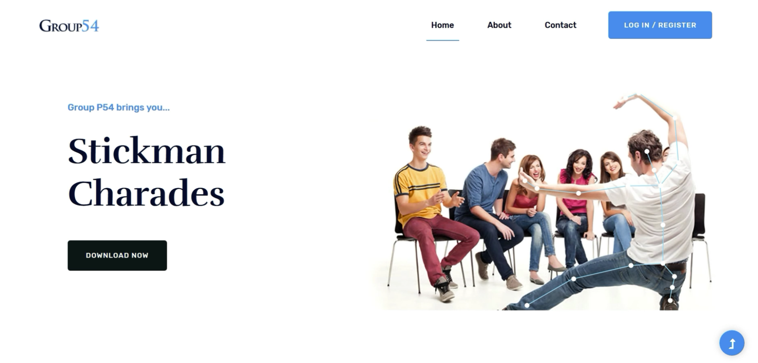

## Step 1 - Register on our platform

Go to our website at <http://192.168.160.20:54081> and click on “Download Now” (you will be redirected to the registration page).

Fill in the form and click on “Complete Registration”. The Downloads page should appear.

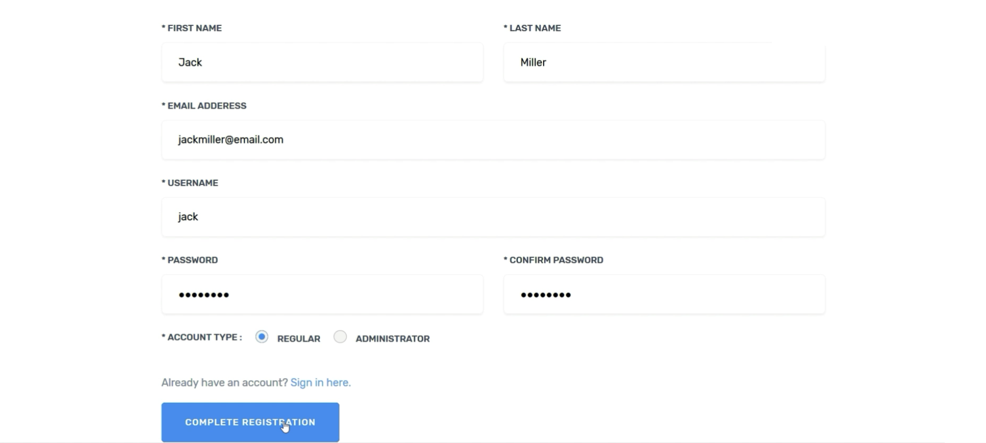

## Step 2 - Download the desktop application

Choose the version you wish to download for your Operating System and click on the highlighted text.

A pop-up window should appear, choose “Save File” and, if available, choose the destination folder.

Wait for the download to be completed and locate the .zip file.

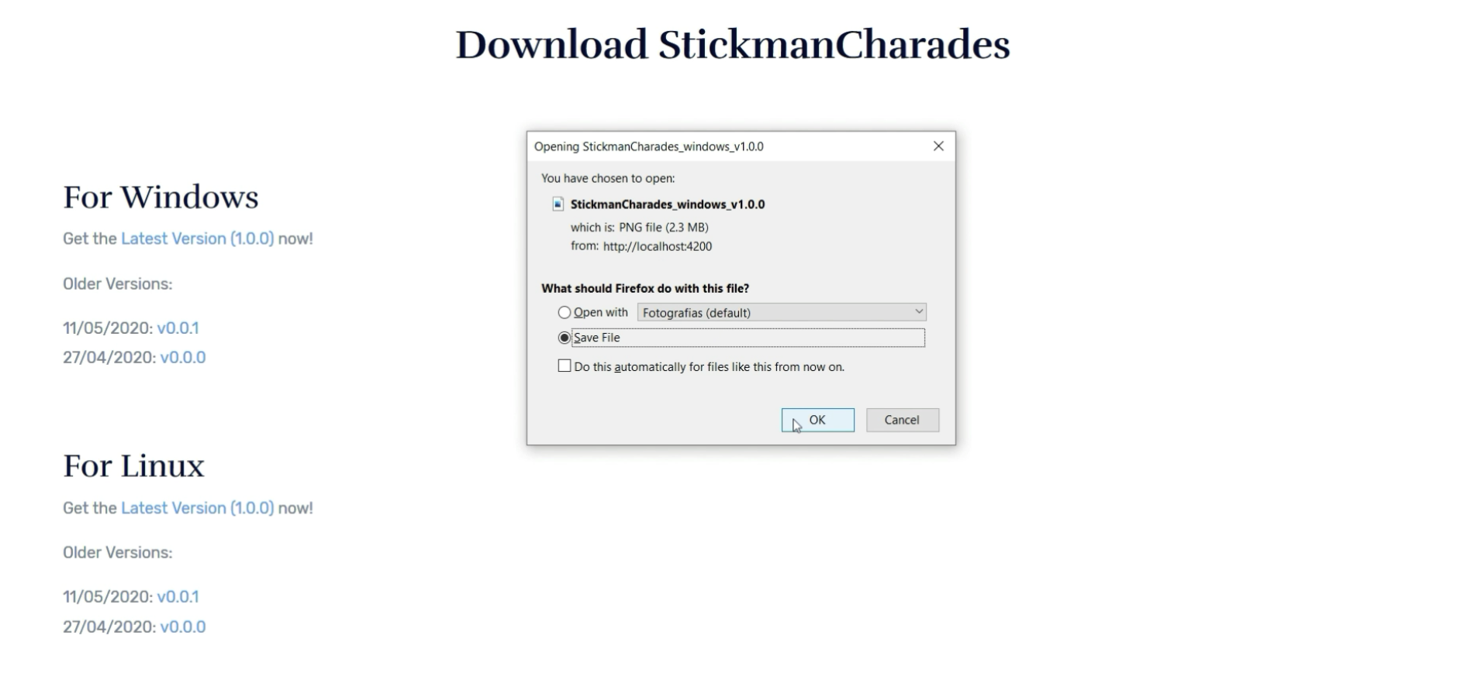

## Step 3 - Decompress and Run the application

After downloading the .zip file containing a version of the desktop application, decompress it and open the directory generated.

All of the dependencies are included in this folder, as well as the binaries of Stickman Charades, so you can simply run the executable file “StickmanCharades.exe” and enjoy the game.

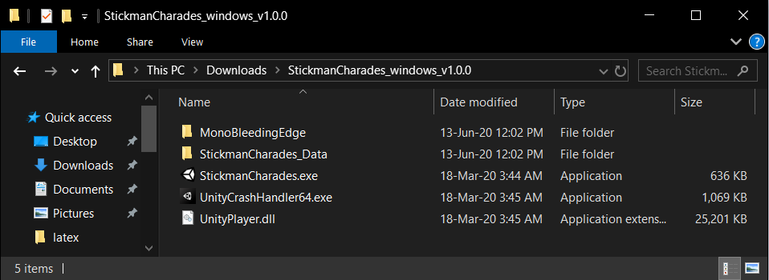

# 2. Game Sessions

Once you have installed Stickman Charades’ desktop application and started it, you will be asked to sign in with the credentials created on registration.

After that, you will be presented with the main menu.

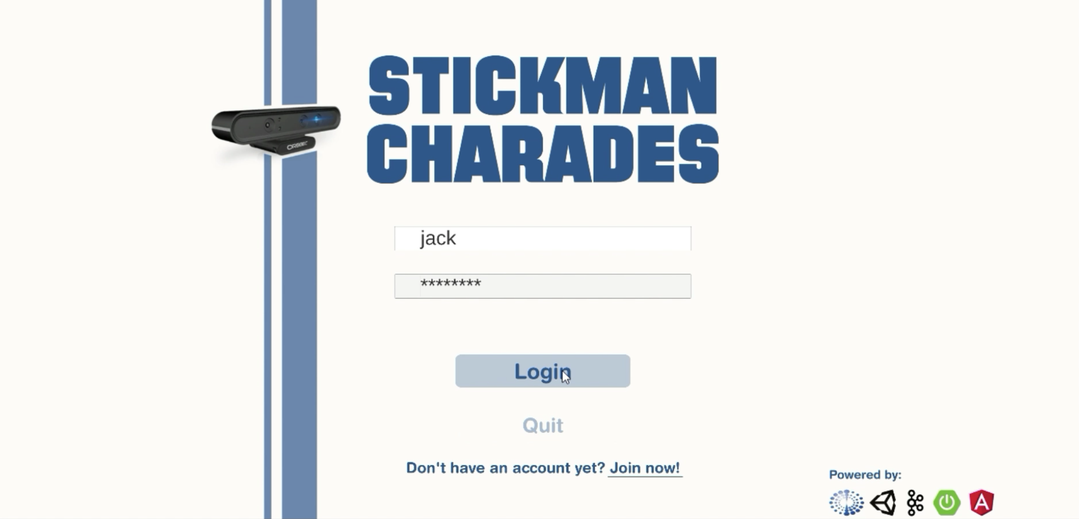

## 2.1. Menu Organization

The main menu contains 4 buttons: Create Session, Join Session, Options and Quit.

The Quit button, as the name suggests, exits the application.

The Options button is meant to tweak the interface and personalize the game.

The Join Session will redirect you to a menu containing all of the currently open sessions so that you can request to join one of them.

The Create Session opens the session creation menu.

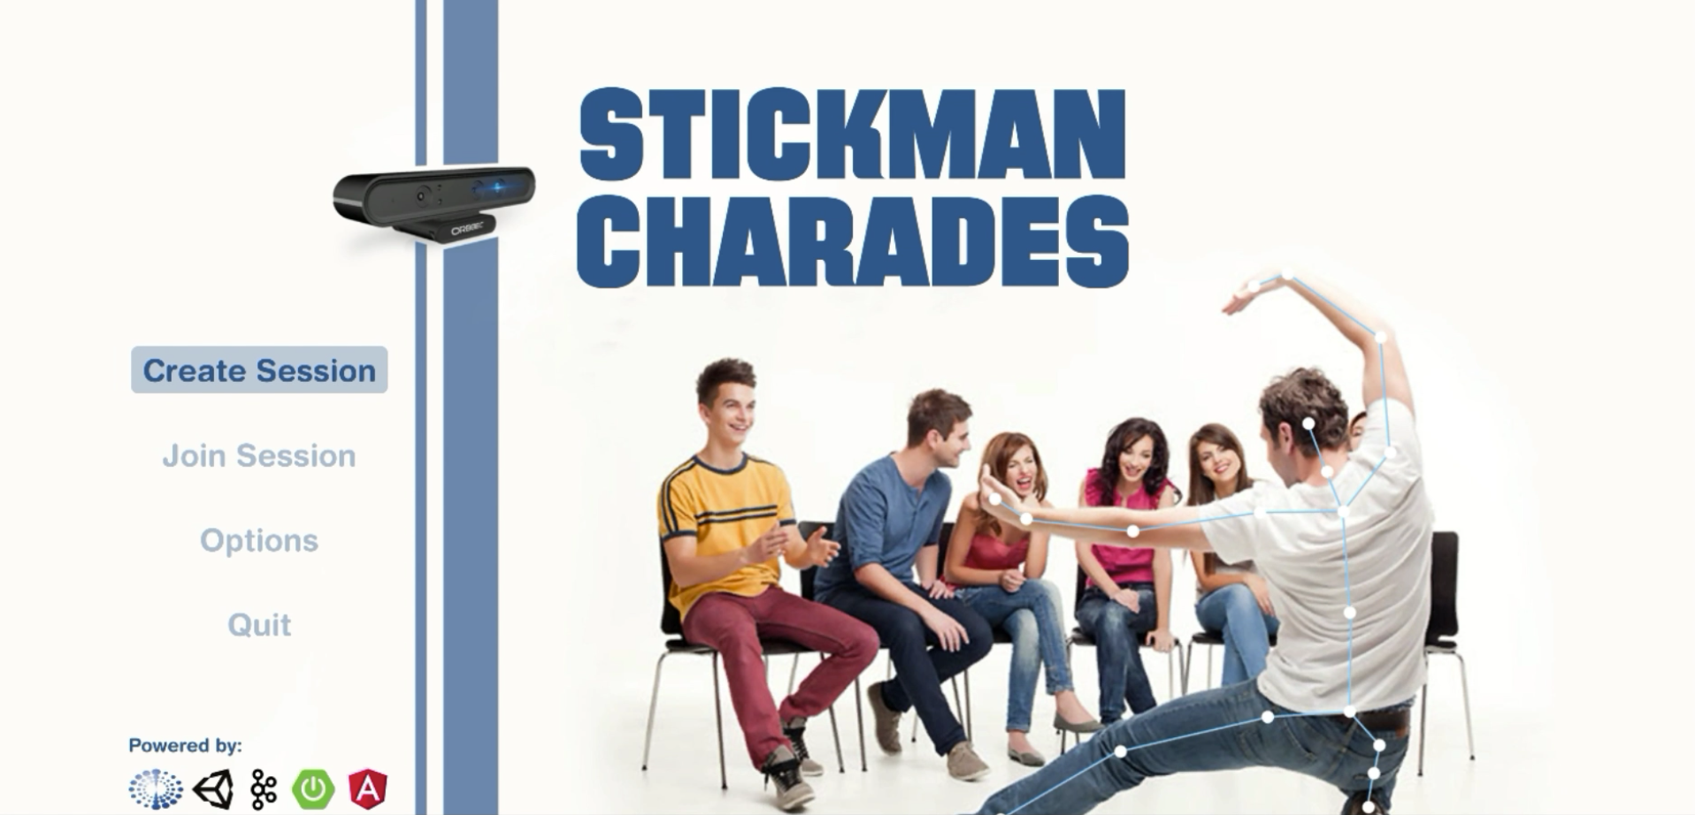

## 2.2. Creating a Game Session

When creating a game session, you can define its name, duration (in minutes) and maximum number of players.

You can also define the words which will have to be discovered by other players based on the movements and poses that the actor (the player chosen to act in front of the depth camera) executes.

Additionally, you can choose amongst a list of avatars which you wish to represent you during the game. This is meant to conceal the identity of players while still allowing to differentiate each other.

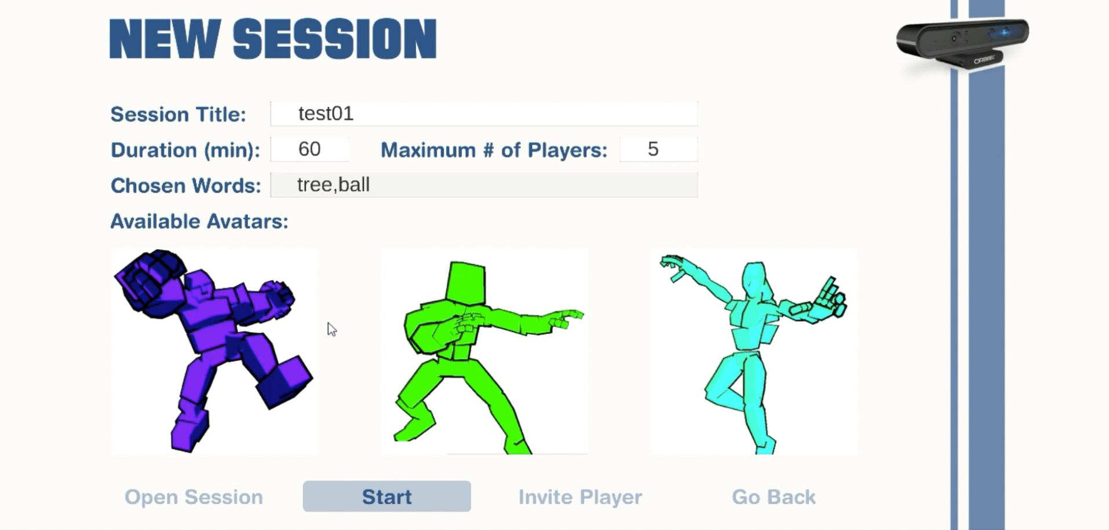

Once you have made your choices, you can proceed to open the session. Only then will the session be available for other players to enter and participate.

Once the maximum number of players is reached or you are satisfied with those that have already joined, you can proceed to start the session.

At this stage the time counter begins and all players can start executing their roles.

Have fun!

## 2.3. Gameplay Commands

As an actor during a game session, you have a few gesture commands available with specific purposes. These are mostly for managing sessions and not so much for the gameplay itself.

For example, by raising your hands above your head, you notify our administrators that something is wrong and should be addressed by an imparcial entity (e.g. hacking, bugs, etc.).

# 3. Additional Remarks

## 3.1. Contact Us

As a Stickman Charades user, you can send us suggestions or complaints via email through our website. You can also contact us through our GitHub repository to collaborate as a developer.

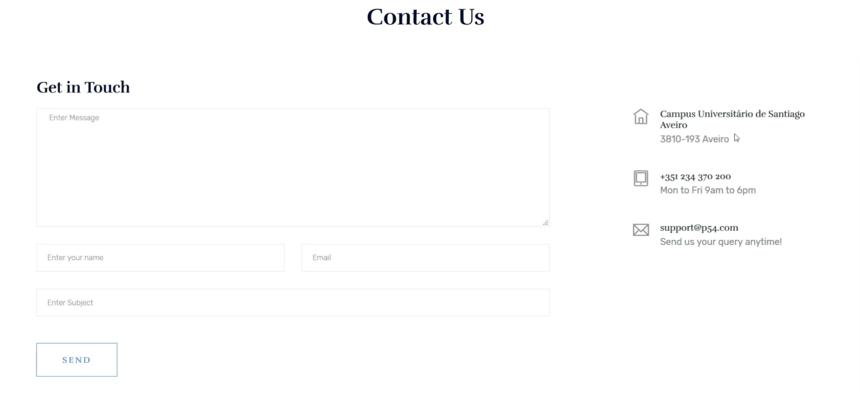

## 3.2. For Developers

We also provide a Developer Manual for those who wish to collaborate on the improvement of Stickman Charades. There, you will find instructions on all areas, so whether you’re a web designer, a game developer or an infrastructure operator, we welcome you!

## 3.3. Final Remarks

We would like to thank our professor José Fernandes ([jfernan@ua.pt](mailto:jfernan@ua.pt)) for guiding us through the development of Stickman Charades and providing us with the infrastructure to host it.